|  |
| --- |
| Fontys Hogescholen |
| Van Halen Project |
| Requirement Analysis Document |

|  |
| --- |
| Van Halen Project group  2-3-2020 |

Table of contents

1. Introduction 2

1.1 Purpose of the system 2

1.2 Scope of the system 2

1.3 Objectives and success criteria of the project 2

1.4 Definitions, acronyms and abbreviations 3

1.5 References 3

2. Current system 4

3. Proposed system 5

3.1 Overview 5

3.2 Functional requirements 5

3.3 Nonfunctional requirements 6

3.3.1 Usability 6

3.3.2 Reliability 6

3.3.3 Performance 6

3.3.4 Supportability 6

3.3.5 Implementation 6

3.3.6 Interface 6

3.3.7 Packaging 6

3.4 System models 7

3.4.1 Scenarios 7

3.4.2 Use case models 8

3.4.3 Analysis object model 8

3.4.4 Dynamic model 8

3.4.5 User interface 9

## Version history

|  |  |  |
| --- | --- | --- |
| Date | Version | Remark |
| 02-MAR-2020 | 0.1 | Initial version |
|  |  |  |
|  |  |  |

# 1. Introduction

## 1.1 Purpose of the system

The purpose of the Van Halen system(VHS) is to ease the task of sorting Skittles using an automated sorting machine. The machine is controlled by a centralized server which in turn is controlled by a user friendly web application. All data collected will be stored on a central location.

## 1.2 Scope of the system

The VHS consists of the following sub systems:

* **Van Halen Sorting Machine(VHSM).** The actual machine sorting the Skittles into various containers. The VHSM is controlled by the Van Halen Central Server.
* **The Van Halen Central Server(VHCS).** The VHCS forms the backbone of the system and ties all the sub systems together.
* **The Van Halen Database(VHDB).** The VHDB is used to store all historical data for logging purposes. This data includes operating data, sorting data and different counters.
* **The Van Halen Web Application(VHWA).** The VHWA is used by the user to control the entire system and provides the possibility for input and output to the user.

## 1.3 Objectives and success criteria of the project

The main objective of the project is to help the users sort Skittles automatically and record data which can be analyzed in the future. In order for the project to be a success the following criteria must be met, divided by sub system:

**The Van Halen Sorting Machine(VHSM).**

The VHSM sub system is deemed successful if the machine performs in accordance with the given functional requirements by the customer as defined in chapter 3.2.

The machine is also expected to accomplish given tasks with an accuracy of at least 95%. This can be measured by the data stored in the VHDB.

**The Van Halen Central Server(VHCS).**

The VHCS sub system is deemed successful if the server software can be used in accordance with the given functional requirements by the customer as defined in chapter 3.2.

**The Van Halen Database(VHDB).**

The VHDB sub system is deemed successful if the server software can be used in accordance with the given functional requirements by the customer as defined in chapter 3.2.

**The Van Halen Web Application(VHWA).**

The VHWA sub system is deemed successful if the server software can be used in accordance with the given functional requirements by the customer as defined in chapter 3.2.

## 1.4 Definitions, acronyms and abbreviations

|  |  |
| --- | --- |
| **Abbreviation** | **Definition** |
| VHP | Van Halen Project |
| VHS | Van Halen System |
| VHWA | Van Halen Web Application |
| VHCS | Van Halen Central Server |
| VHDB | Van Halen Database |
| VHSM | Van Halen Sorting Machine |

## 1.5 References

The customer has functional requirements and use cases. This document has taken into account these customer requirements. All requirements given by the customer are bundles for reference in document “**Customer Requirements Van Halen Project**”.

# 2. Current system

There is currently no automated system in place for sorting Skittles and recording data. The Skittles are currently sorted manually and there are no records kept.

# 3. Proposed system

## 3.1 Overview

The Van Halen System comprises an automated sorting machine(VHSM), a centralized server(VHCS), a web application(VHWA) and a database server(VHDB).

The user will control the system using the VHWA. The VHWA is used to collect user input and display system output to the user. The VHWA communicates solely with the VHCS.

The VHDB is used to store historical information that is generated by the system. The VHCS is solely used by the VHCS.

The VHSM will be able to accept a batch of Skittles and sort them according to the task given by the user. The VHSM will not perform any logic calculations, these calculations are done by the VHCS. The VHSM will be in charge of scanning the Skittle’s color and transporting Skittle to the correct container which is given by the VHCS.

The VHCS is the central system tying everything else together. The VHCS will accept user input and send system output to the VHWA. The VHCS will control the VHSM. The VHCS will collect and send data to the VHDB.

## 3.2 Functional requirements

The functional requirements for the Van Halen system are:

* The user can create an account.
* The user can login to the web application.
* The user can start and stop the sorting process form the web application.
* The user can sort for specified color or colors .
* The user can sort all colors.
* The user can enter the amount of Skittles to sort.
* The user can enter the amount of Skittles of a given color he or she wishes to obtain.
* The user can view the status of the sorting process in real time including amount per color.
* All sorting job data will be persistently stored for future reference.
* The user can view personal sorting job history.
* The user will receive feedback when the sorting process has finished and whether or not the sorting was successful.
* The system will alert a user if the connection between the interface and sorting machine is interrupted.
* The sorting machine will detect the Skittle to sort.
* The sorting machine will process one Skittle at a time.
* The sorting machine will scan the color of given Skittle.
* The sorting machine will route the Skittle to the desired container.
* The sorting machine will detect an empty feeding container and give feedback to the user.
* The sorting machine will detect a full container and give feedback to the user.

## 3.3 Nonfunctional requirements

The nonfunctional requirements are the requirements not directly linked to the functionality the system has to provide.

### 3.3.1 Usability

The user must be able to use the web application on multiple devices including a PC(desktop or laptop) and mobile devices including android smartphones.

The system will only allow a maximum of one concurrent user at any time.

### 3.3.2 Reliability

The sorting machine will need to detect and sort colors with an accuracy of at least 95%.

### 3.3.3 Performance

There are no explicit specifications regarding performance of the system other than the system must work fluent for the end-user.

### 3.3.4 Supportability

The system will be designed to work without maintenance. The software will be made modular and documentation for the system will be provided to ensure software maintenance is possible.

### 3.3.5 Implementation

The system will be implemented as follows:

The Van Halen Central server and Web Application will be released as an archive(ZIP) and can be extracted and run on any JAVA capable system including Windows and Linux operating systems.

The Van Halen Database will be released as an archive(ZIP) and can be extracted and run on any JAVA capable system including Windows and Linux operating systems. The software will user a locally installed database server in order to store the data provided.

The Van Halen Sorting Machine(VHSM) will be released as a working prototype. The operating software will be released as an archive(ZIP) and can be uploaded to the VHSM as needed.

### 3.3.6 Interface

The system will not interface with external systems. It will however interface between the different Van Halen subsystems. The interfaces will be described and documented further in the system design documentation.

### 3.3.7 Packaging

As this is a prototype system there will be no physical packaging.

## 3.4 System models

### 3.4.1 Scenarios

The Van Halen system will support the following scenarios:

As a user, I can create an account in order to use for logging into the web application.

As a user, I can login to the web application in order to use the sorting machine.

As a user, I can start and stop the sorting process form the web interface so that the sorting machine can be used safely.

As a user, I can pick colors in order to sort them according to my preferences.

As a user, I can sort all different colors to different containers.

As a user, I can enter an amount so that the sorting machine will stop sorting once that number is reached.

As a user, I can enter an amount and color so that the sorting machine will stop sorting once the number of the given color is reached.

As a user, I receive feedback from the system in order to monitor the status of the sorting job and the machine.

As a user, all my sorting data will be saved to a database so that it can be used for future reference including viewing my personal job history.

As a user, I can fill the sorting machine with Skittles in order for the sorting machine to user for the sorting jobs.

### 3.4.2 Use case models



### 3.4.3 Analysis object model

To do

### 3.4.4 Dynamic model

To do

### 3.4.5 User interface

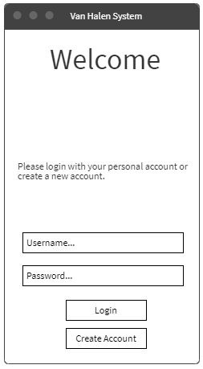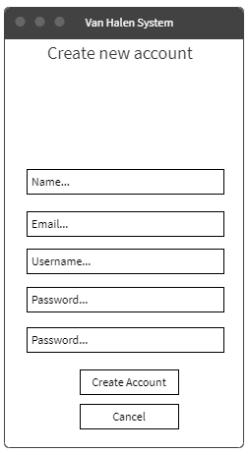

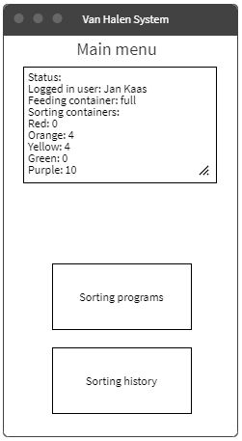

More to do